March 2011

**EE3320 Test 1**

**Total Marks = 100**

**Question 1.** **(10 marks)**

Suppose within your web browser you click on a link to obtain a web page. Suppose that web page associated with the link contains a small amount of HTML text. Let RTT denote the round trip time between the local host and the server containing the HTML file. Further suppose the page references five very small objects. Assuming zero transmission and queueing time of the objects, how much time is needed from when the client clicks on the link until the client receives all the five referenced the objects with

i. non-persistent HTTP with parallel TCP connections but the maximum number of parallel connections is set to two? [2 marks]

ii. non-persistent HTTP with parallel TCP connections but the maximum number of parallel connections is set to four? [2 marks]

iii. non-persistent HTTP with no parallel connections? [2 marks]

iv. persistent HTTP with pipelining? [2 marks]

v. persistent HTTP without pipelining? [2 marks]

i.  .

ii.  .

iii..

iv.  .

v.  ** **.

**Question 2.** **(38 marks)**

a) With the help of a diagram containing client(s), proxy server and origin server, explain how the proxy server responds to the situations when there are a hit and a miss, respectively. [8 marks]

* Hit (i.e. object in proxy server) : the proxy server returns the requested object to the client (i.e. Client 2 in this case)
* Miss (i.e. object not in proxy server): the proxy server requests the requested object from the origin server, and then returns the object to the client (i.e. Client 1 in this case)



b) Consider Figure Q. 2, in which there is an institutional network connected to the Internet. Suppose that the average object size is 800,000 bits and that the average request rate from the institution’s browsers to the origin servers is 90 requests per minute. Also suppose that the amount of time it takes from when the router on the Internet side of the access link forwards an HTTP request until it receives the response is three seconds on average. Model the total average response time as the sum of the average access delay (that is, the delay from the Internet router to the institution router) and the average Internet delay. For the average access delay, use *T*/(1−*TB*), where *T* is the average time required to send an object over the access link and *B* is the arrival rate of objects to the access link.

i. Find the total average response time. [6 marks]

ii. Now suppose a cache is installed in the institutional LAN. Suppose that the hit rate is 0.4. Find the total average response time. [6 marks]

iii. Now suppose a cache is installed in the router on the Internet side of the access link. Suppose that the hit rate is 0.4. Find the total average response time. [6 marks]

iv. What is the total average response time if we upgrade the access link to the speed of 5 Mbps instead of installing a cache in the institutional LAN? If the speed of the access link can be further increased, what is the minimum possible value for the total average response time? [6 marks]

v. What is the result of ii. if we consider the delay caused by the LAN? [6 marks]

Origin servers

public Internet



Institutional network

10 Mbps LAN

4 Mbps

access link



Figure Q.2

i. The time to transmit an object of size *L* over a link with rate *R* is *L/R*. The average time is the average size of the object divided by *R*:

T= (800,000 bits)/(4,000,000 bits/sec) = 0.2 sec

The traffic intensity on the link is *TB* = (90/60)(0.2) = 0.3. Thus, the average access delay is *T*/(1−*TB*) = (0.2 sec)/(1− 0.3) = 0.286 seconds. The total average response time is therefore 0.286 sec + 3 sec = 3.286 sec.

ii. The traffic intensity on the access link is reduced by 40% since the 40% of the requests are satisfied within the institutional network. Thus the average access delay is *T*/(1−*TB*)=(0.2 sec)/[1 – (0.6)(0.3)] = 0.244 seconds. The response time is approximately zero if the request is satisfied by the cache (which happens with probability .4); the average response time is 0.244 sec + 3 sec = 3.244 sec for cache misses (which happens 40% of the time). So the average response time is (0.4)(0 sec) + (0.6)( 3.244 sec) = 1.946 seconds. Thus the average response time is reduced from 3.286 sec to 1.946 sec.

iii. The time to transmit an object of size *L* over a link with rate *R* is *L/R*. The average time is the average size of the object divided by *R*:

T= (800,000 bits)/(4,000,000 bits/sec) = 0.2 sec

The traffic intensity on the link is *TB* = (90/60)(0.2) = 0.3. Thus, the average access delay is *T*/(1−*TB*) = (0.2 sec)/(1− 0.3) = 0.286 seconds. The total average response time is therefore 0.286 sec + 0.4×0 sec + 0.6×3 sec = 2.086 sec.

iv. Now, the access link is updated with the speed of 5 Mbps instead of installing a cache in the institutional LAN.

T= (800,000 bits)/(5,000,000 bits/sec) = 0.16 sec

The traffic intensity on the link is *TB* = (90/60)(0.16) = 0.24. Thus, the average access delay is *T*/(1−*TB*) = (0.16 sec)/(1− 0.24) = 0.211 seconds. The total average response time is therefore 0.211 sec + 3 sec = 3.211 sec. The minimum possible value for the total average response time is 3 sec.

v. The time to transmit an object of size *L* over the LAN with rate *R* is *L/R*. Therefore, the delay caused by the LAN is the average size of the object divided by *R*:

T= (800,000 bits)/(10,000,000 bits/sec) = 0.08 sec. Therefore, the total average response time with the consideration of the delay caused by the LAN is 1.946 seconds + 0.08 seconds = 2.026 seconds.

**Question 3.** **(20 marks)**

With reference to Fig. Q3 showing TCP disconnection procedure, when TCP receives a FIN from the other TCP, TCP needs to go through two wait states (CLOSE WAIT and LAST ACK) before closing the connection. Please answer the following:

a) What may go wrong if Site 2 only sends “FIN seq=y, ACK x+1” but not send “ACK x+1”?

[4 marks]

b) What may go wrong if Site 2 sends “FIN seq=y, ACK x+1” instead of “ACK x+1”?

[4 marks]

c) What may go wrong if “ACK segment” from Site 2 is lost? [4 marks]

d) What may go wrong if “ACK segment” from Site 1 is lost? [4 marks]

e) What is the advantage that Site 2 sends “FIN seq=y, ACK x+1” instead of “FIN seq=y”?

[4 marks]

Answer of Question 3:

a) The timer at Site 1 for the ACK of “FIN seq=x” may be timeout. This causes Site 1 to resend “FIN seq=x” unnecessarily and wastes bandwidth resource.

b) When Site 2 wants to ACK to the FIN signal from Site 1, Site 2’s application may still have data to send. Therefore, if Site 2 sends “FIN seq=y, ACK x+1” instead of “Send ACK x+1”, Site 2 may close its connection before its application finishes sending out all its data. This will cause data loss.

c) Site 1 will resend “FIN seq=x” after timeout.

d) Site 2 will resend “FIN seq=x” after timeout.

e) The “ACK x+1” previously sent by Site 2 may be lost. By sending “FIN seq=y, ACK x+1”, Site 1 may not need to resend “FIN seq=x” due to the time out of the ACK (“ACK x+1”) for “FIN seq=x”.

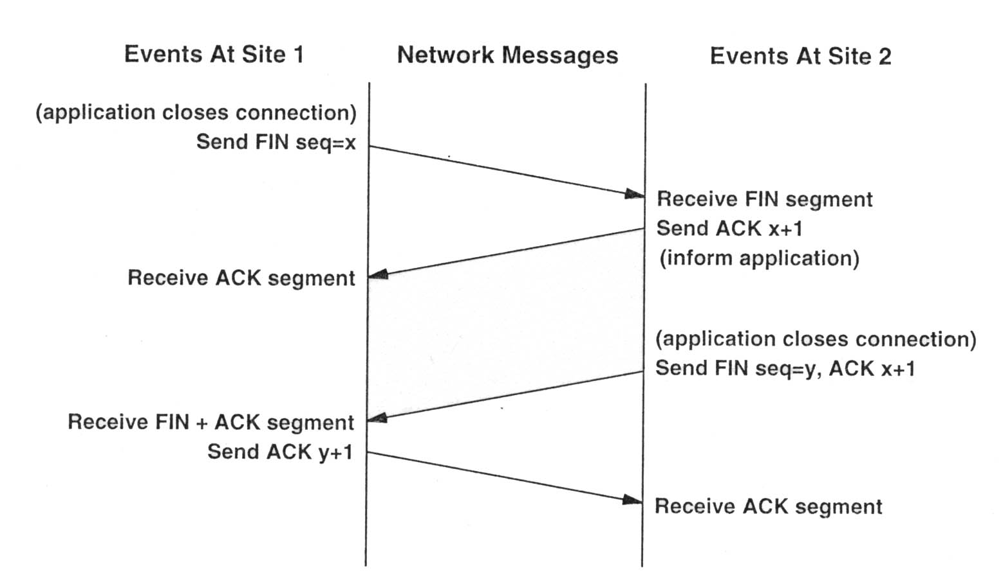

Figure Q.3

**Question 4** **(32 marks)**

Assuming TCP Reno is the protocol experiencing the behavior shown in Table 1, answer the following questions. In all cases, you should provide a short explanation justifying your answer.

Table 1: TCP congestion control

|  |  |  |  |  |  |  |  |  |  |  |  |  |  |  |  |  |
| --- | --- | --- | --- | --- | --- | --- | --- | --- | --- | --- | --- | --- | --- | --- | --- | --- |
| NTR | 1 | 2 | 3 | 4 | 5 | 6 | 7 | 8 | 9 | 10 | 11 | 12 | 13 | 14 | 15 | 16 |
| CWS | 12 | 13 | 14 | 15 | 16 | 1 | 2 | 4 | 8 | 4 | 5 | 6 | 7 | 8 | 1 | 2 |

NTR – number of transmission round (note that transmission round has been renumbered)

CWS – congestion window size

1. Identify the intervals of time when TCP slow start is operating. [4 marks]
2. Identify the intervals of time when TCP congestion avoidance is operating. [4 marks]
3. After the 5th transmission round, in which way is segment loss detected by? [4 marks]
4. After the 9th transmission round, in which way is segment loss detected by? [4 marks]
5. What is the maximum possible initial value of Threshold at the first transmission round?

[4 marks]

1. What is the value of Threshold at the 6th transmission round? [4 marks]
2. What is the value of Threshold at the 10th transmission round? [4 marks]
3. What would be the congestion window size and the value of Threshold if the segment loss at the 15th transmission round is not due to timeout? [4 marks]
4. TCP slowstart is operating in the intervals [6,8] and [15,16]: double the previous window size
5. TCP congestion avoidance is operating in the intervals [1,5] and [9,14]: linearly increase the window size
6. After the 5th transmission round, segment loss is detected due to timeout, and hence the congestion window size is set to 1.
7. After the 9th transmission round, packet loss is recognized by a triple duplicate ACK. If there was a timeout, the congestion window size would have dropped to 1.
8. The maximum possible initial value of the threshold at the first transmission round is 12 since when the congestion window size is 12, TCP congestion avoidance is operating.
9. The threshold is set to half the value of the congestion window when packet loss is detected. When loss is detected during transmission round 5, the congestion windows size is 16. Hence the threshold is 8 during the 6th transmission round.
10. The threshold is set to half the value of the congestion window when packet loss is detected. When loss is detected during transmission round 9, the congestion windows size is 8. Hence the threshold is 4 during the 10th transmission round.
11. The congestion window size and the threshold value are both reduced to 4.